**Project Design Phase-I**

**Solution Architecture**

**Team id: B3-3M5E**

**Date:12.october.2022**

**IoT Based Safety Gadget for Child Safety Monitoring and Notifications**

**Solution Architecture:**

We can use both web application as well as mobile application or either one of it as the front end user interface, cloud, and database as the back end for storing and retrieving information, and a device for monitoring.

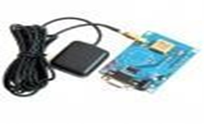

GPS is used to track the live location of the child who is wearing that device. With the help of GPS, we can easily perform Geo-fencing concept, in which we will be able to feed a particular boundary to that device

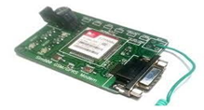

The Temperature sensor is used to sense the surrounding temperature of the device. If the temperature level exceeds the room temperature then the alert message will be sent using GSM to the specified users.

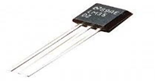

The Pulse sensor is used to detect any abnormal feelings experienced by the child like fear, anxiety, nervousness, drowsiness and several other illnesses which manipulates the normal heart rate.



These values are used to alert the specified guardians through SMS using GSM. When the user receives these alert messages from that device, they can turn on the web camera placed in that device, with which they can visually monitor the status of that child through the live video stream.

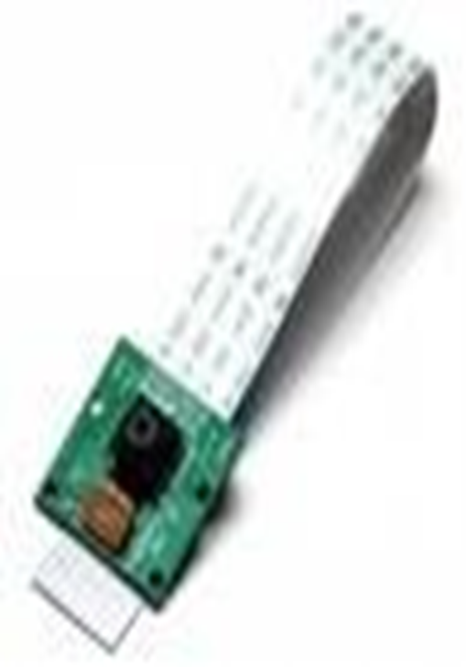

.

**Solution Architecture Diagram:**

